CIRCLE GEOMETRY

Extended investigation Part 1: Preparation activity
Solutions

Question 1

Central Angle: An angle whose vertex is at the centre and whose sides are radii.

Chord: An interval joining two points on the circle.

Cyclic quadrilateral: A cyclic quadrilateral is a quadrilateral whose vertices all lie on a circle.

Diameter: A chord that passes through the centre.

Radius: Any line segment joining a point on the circle to the centre.

Major/Minor Arc: A part of the circumference of the circle. A major arc represents more than half of the circumference; a minor arc represents less than half of the circumference.

Major/Minor Segment: The part of the circular region enclosed between a chord (not a diameter) and the circle. A major segment encloses a region greater than that of the semicircle; a minor segment encloses a region smaller than that of the semicircle.

Alternate Segment: The word ‘alternate’ means ‘other’. The chord AB divides the circle into two segments and AU is tangent to the circle. Angle APB ‘lies in’ the segment on the other side of chord AB from angle BAU. We say that it is in the alternate segment.
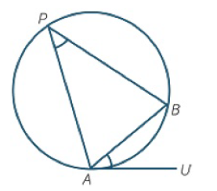

Major/Minor Sector: The portion of a circular region bounded by two radii and an arc. A major sector covers a region greater than that of the semicircle; a minor sector covers a region smaller than that of the semicircle.

Secant: A line that cuts a circle at two distinct points.

Semicircle: Half a circular region, formed by the diameter and half the circle.

Tangent: A line that intersects a circle at one point.

Question 2

(a) The angle formed by the diameter and two chords lies in a semicircle.

(b) The size of the angle remains unchanged.

(c) The angle in a semicircle is a right angle.

Question 3
Angle in a Semicircle Theorem

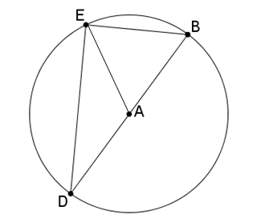

Given: Circle centre A, diameter BD. E is any point on the circle, ∠BED is an angle in the semicircle DBE.

To Prove: ∠BED = 90°

Extension to
the diagram: Draw AE.

Proof:
Question 4

(a) arc CD

(b) ∠CAD = 2 x ∠CBD

(c) The size of the angle at the centre subtended by an arc of the circle is twice the size of the angle at the circumference subtended by the same arc.

Question 5

Central Angle Theorem
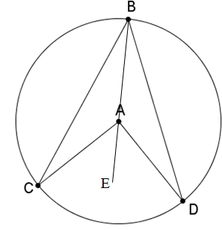
Given: Circle centre A. ∠CAD is the angle subtended by arc CD at the centre and ∠CBD is the angle subtended by arc CD at the circumference

To Prove:

Extension to
the diagram: Join BA and produce it to E.

Proof:

Question 6

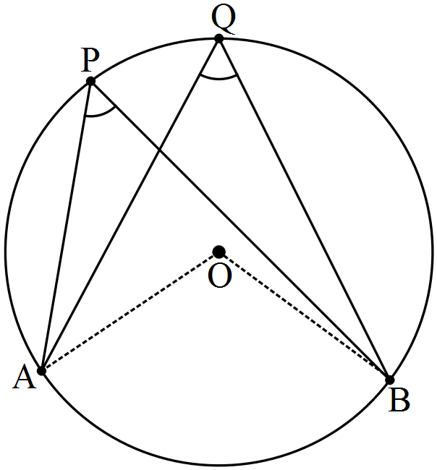
Given: Circle centre O. ∠APB and ∠AQB are angles at the circumference subtended by arc AB.

To Prove:

Proof:

Question 7

(a) The two angles are the same size.

(b) An angle between a chord and a tangent is equal to any angle in the alternate segment.

Question 8

(a) The tangents from C to the circle are equal in length.

(b) Tangents drawn to a circle from an external point are equal in length.

Question 9

(a) The products are the same.

(b) When two chords of a circle intersect, the product of the lengths of the intervals on one chord equals the product of the lengths of the intervals on the other chord.

Question 10 (a)

Question 10 (b)

Question 10 (c)

